

**Computer Networks Laboratory**

**Course code: CSE 324**

Project Title**:**

**IoT for Smart University**

Group Members**:**

**1) Mohammad Al-Shariar**

**ID: 011 151 007**

**2) Sumaiya Mahmud**

**ID: 011 151 028**

**INTRODUCTION:**

Smart University is a “university which enhances the education, research, and work experience of stakeholders by incorporating digital, innovative, and internet-based technologies for the betterment of the society at-large.” A “Smart University” is not a destination, or a milestone, it is rather a continuation of the journey of progress of Universities’ role to serve humanity. A smart University focuses on Smart Campus, Smart People, Smart Education, Smart Research, Smart Governance, and Smart Influence.

**OBJECTIVE**:

The objective of Smart University is to provide conducive environment to the students and researchers helping them in their research and learning opportunities to keep pace with 21st century.

**PROBLEM STATEMENT:**

* To avoid the wastage of Electricity
  + Sometimes we forget to switch off of AC, Fan Lights.
* To minimize the chances of fire accidents
* To solve the university parking places problems
* To ensure the use of internet everywhere
* To provide automated and smart education environment
* To minimize disruption of concentration in activities
* To improve the security system of University.

**MOTIVATION:**

Smart university and smart education are emerging and rapidly growing areas that represent an integration of

* smart and intelligent systems, smart objects and smart environments,
* smart technologies, various branches of computer science and computer engineering,
* state-of-the-art smart educational software and/or hardware systems, agents and tools, and
* Innovative pedagogy and advanced technology-based teaching strategies and learning methodologies.

**PROJECT FEATURES:**

* Smoke and Fire detection system.
* Human presence detection system using motion sensor.
* Smart security system where solar panel is used.
* Smart parking system using RFID.
* Smart university campus where internet is everywhere.
* Smart class room and lab.

**PROJECT COMPONENTS:**

* **Sensors:** 
  + - Temperature sensor, Smoke sensor, IR sensor, Motion detection sensors, furnace , Humidity sensors
* **IT Components:**
  + - Trip sensor, Camera, Light, Alarm, Door, RFID Reader, Window, Fan, Fire Monitor, Fire Alarm, AC, Street Lamp, Wind Detector.
    - **Others :** MCU, SBC, Router, Switch, Home Gateway, Home Router, Cell Tower, Central-office Server
* **Actuators:**
  + - Air Cooler, Alarm

**PROJECT IMPLEMENTATION:**

* Setting up Registration Server
* Connect a wireless router and complete routing configuration
* Connect the necessary sensors with the MCU and SBC
* Necessary coding implementation
* Connect the MCU and other IoT components with the router
* Provide necessary condition on the registration server for having IoT devices interconnectivity

**ADVANTAGES:**

* Cost-effective
* Automated system
* Immediate actions against fire accidents
* Saving human resource and time
* Technical-LEVEL management is easier than ground-level management

**FUTURE WORK:**

* Real-life implementation
* Alert nearest fire brigade
* Automated system in management levels

**CONCLUSION:**

This Project is simple, efficient and user-demanding. There is High possibility to be built and implemented at various levels. It can be selling as a blueprint in the software market.

Project demonstration: Smart University includes smart class room, smart, faculty room, it room, server room, computer lab, boys-playing room, solar paneled security room, smart parking place and university campus.

Smart Classroom:

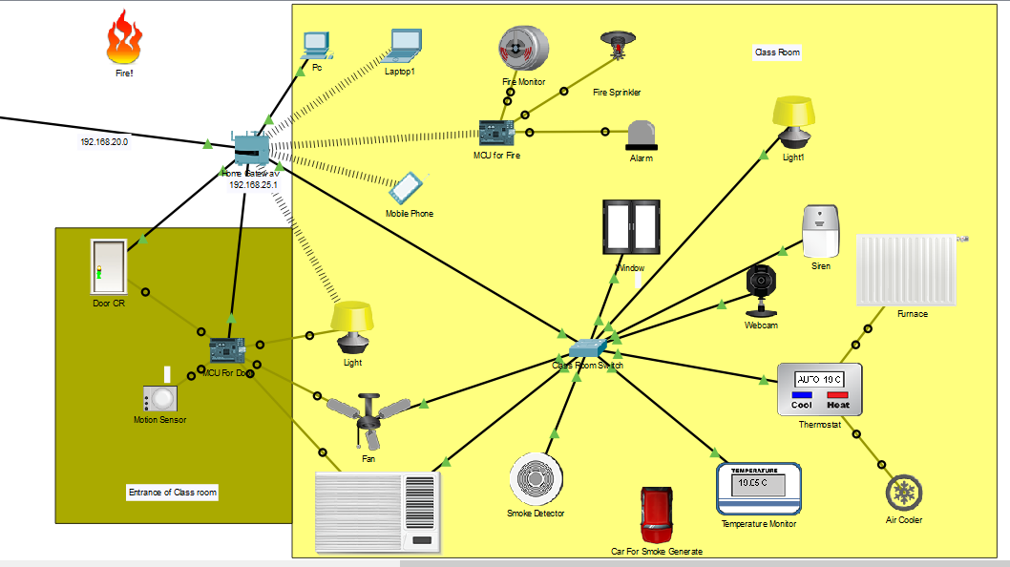

Here, most important part is automated door and automated light and fan, AC. Light, Fan, AC, Door is connected with motion sensor and when sensor detect object in front of door then door automatically open and light, fan, AC will also automatically on. Other feature of the room is automated fire detection system.

Faculty Room:

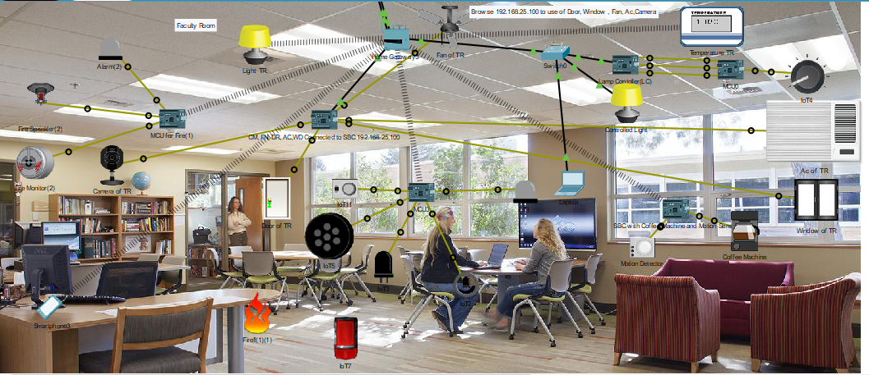

IT Room:

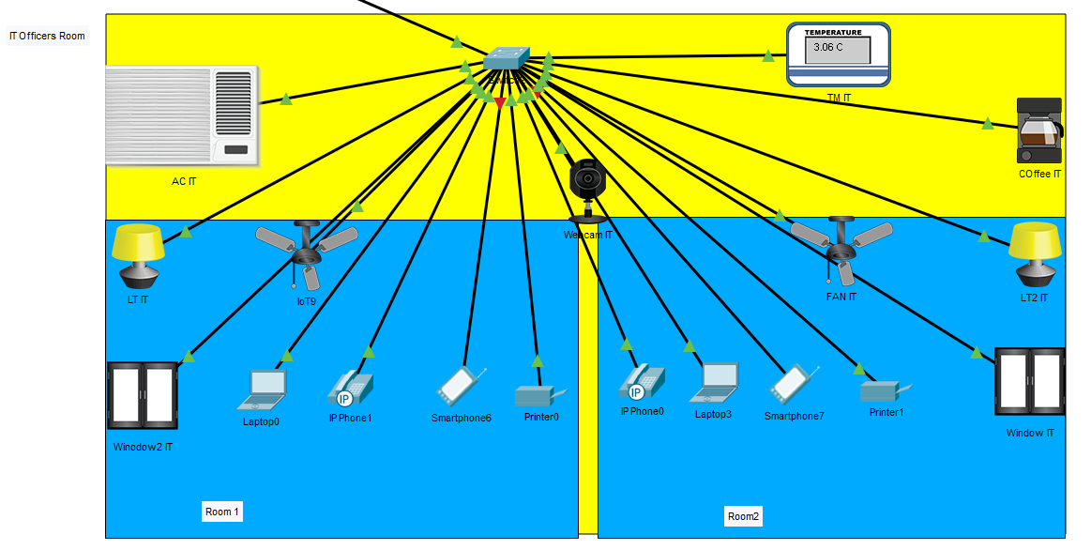

Computer Lab:

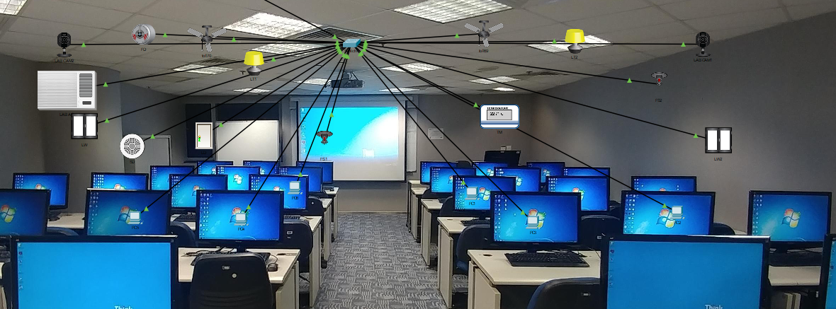

Solar planed security system:

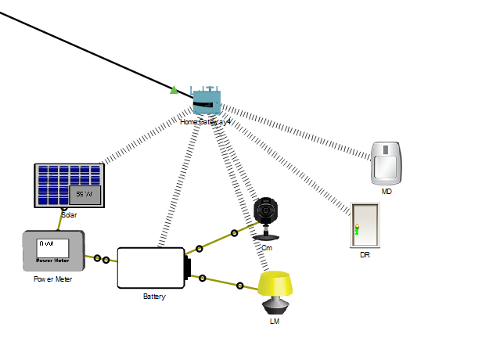

Student-Playing room:

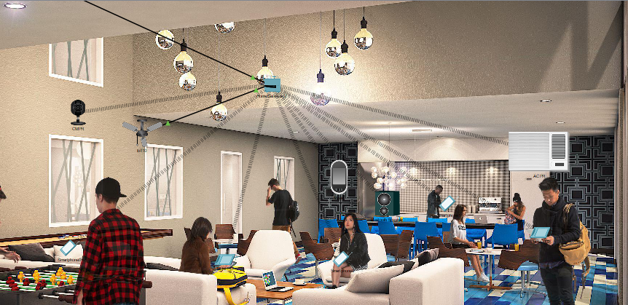

University Fields:

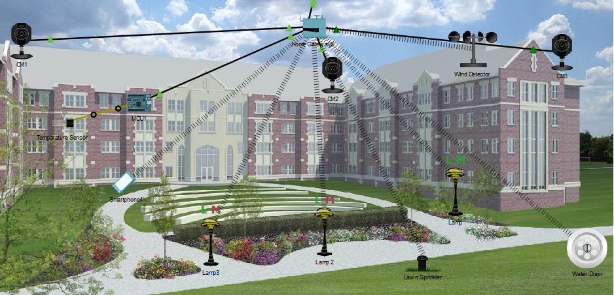

University Campus

Automated parking yatem:

